

WebMinds, Inc.

TM

Version v7.0

User Manual (For Windows Users)

Version

Copyright © WebMinds, Inc., 2024

All Rights Reserved

This publication is protected by federal copyright law. No part of this publication may be copied or distributed, stored in a retrieval system, or translated into any human or computer language in any form or by any means, electronic, mechanical, magnetic, manual or otherwise, or disclosed to third parties without the express written permission of **WebMinds, Inc.**

**WebMinds, Inc.** makes no representation or warranties with respect to the contents hereof and specifically disclaim any implied warranties of merchantability or fitness for a particular purpose. Further, **WebMinds, Inc.** reserves the right to revise this publication and to make changes from time to time in the contents hereof without obligation of **WebMinds, Inc.** to notify any person or organization of such revision or changes.

**WebMinds, Inc.** has prepared this guide for use by **WebMinds, Inc.** personnel and authorized third parties as a guide to proper operation and/or maintenance of **WebMinds, Inc.** equipment and software. The drawings and specifications contained herein are the property of **WebMinds, Inc.**

Trademarked names may appear throughout this user manual. Rather than list the names and entities that own the trademarks or insert a trademark symbol with each mention of the trademarked name, the names are used only for editorial purposes and to the benefit of the trademark owner with no intention of infringing upon that trademark.

Address comments and corrections to:

**WebMinds, Inc.**

950 N Collier Blvd. Suite 400

Marco Island FL 34145

USA

Revision History

|  |  |  |  |
| --- | --- | --- | --- |
| Date | Release | Revision DESCRIPTION | MODIFIED BY |
| Mar 01, 2024 | 0.1 | Initial draft | David A. Flynn |
| Mar 14, 2024 | 1.0 | First base lined user manual | David A. Flynn |
|  |  |  |  |
|  |  |  |  |
|  |  |  |  |
|  |  |  |  |

About this User Manual

This user manual contains information about all the features & functionalities of the Duplicate Photo CleanerTM application & instructions on how to use them.

Purpose of this User Manual

The purpose of this user manual is to assist the end users of the TM application.

In Scope of this User Manual

The scope of this user manual includes the description and usage of the TM application.

Out of Scope of this User Manual

The scope of this user manual does not include –

* the detailed installation process of TM application
* the usage of the features and functionalities of your operating system

Intended Audience of this User Manual

The intended audiences of this user manual are –

* end users of the TM application

Organization of this User Manual

This user manual contains 12 chapters & 1 appendices as indicated below –

| chapter | Description |
| --- | --- |
| **Chapter 1** | Introduction |
| **Chapter 2** | Getting Started |
| **Chapter 3** | Registering your DPC Application Installation |
| **Chapter 4** | Activating your DPC Application Installation |
| **Chapter 5** | Removing your DPC License Details |
| **Chapter 6** | Performing a Standard Scan |
| **Chapter 7** | Performing a Mobile SmartScan |
| **Chapter 8** | Performing a Folder Comparison |
| **Chapter 9** | Performing a Picassa Scan |
| **Chapter 10** | Performing a Lightroom Classic Scan |
| **Chapter 11** | Performing a PaintShop Pro Scan |
| **Chapter 12** | Performing a Fragment Search |
| **Appendix A** | Frequently Asked Questions |

Typographical Conventions / Customaries used in this User Manual

The typographical conventions used in this user manual include the following –

* **Note:** The purpose of this typographical convention is to provide important information corresponding to an already stated fact. This is how we depict a note in this user manual –

**Note:**<Note Text><Note Text><Note Text><Note Text><Note Text><Note Text><Note Text><Note Text><Note Text><Note Text><Note Text><Note Text><Note Text><Note Text>

* **Tip:** The purpose of this typographical convention is to provide additional information supplementing an already stated fact. This is how we depict a tip in this user manual –

**Tip:**<Tip Text><Tip Text><Tip Text><Tip Text><Tip Text><Tip Text><Tip Text><Tip Text><Tip Text><Tip Text><Tip Text><Tip Text><Tip Text><Tip Text><Tip Text><Tip Text><Tip Text>

* **Warning:** The purpose of this typographical convention is to provide critical information corresponding to an already stated fact. This is how we depict a warning in this user manual –

**Warning:**<Warning Text><Warning Text><Warning Text><Warning Text><Warning Text><Warning Text><Warning Text><Warning Text><Warning Text><Warning Text><Warning Text>

* **Reference:** The purpose of this typographical convention is to refer you to another section in this user manual or another document or to an external reference. A reference is depicted in the following manner in this user manual –

**Reference:** To read detailed steps, navigate to **<Chapter Name>** chapter by clicking this link.

or

**Reference:** For more information, navigate to **<Chapter Name>** chapter by clicking this link.

Abbreviations / Acronyms used in this User Manual

The table below describes the abbreviations / acronyms used in this user manual –

|  |  |
| --- | --- |
| Abbreviation | Description |
| **GUI, UI** | Graphical User Interface, User Interface |
| **IPR** | Intellectual Property Rights |
| **DPC** | Duplicate Photo Cleaner |
| **TM** | Trade Mark |
| **TOC, TOT, TOF** | Table of Contents, Table of Tables, Table of Figures |
| **PC** | Personal Computer |
| **FAQs** | Frequently Asked Questions |

Terms Used in this User Manual

The below table briefly describes the terms utilized in this user manual –

| chapter | Description |
| --- | --- |
| **End User** | An operator or user of the Duplicate Photo Cleaner TM application. |

Table of Contents

Revision History ii

About this User Manual iii

Purpose of this User Manual iii

In Scope of this User Manual iii

Out of Scope of this User Manual iii

Intended Audience of this User Manual iii

Organization of this User Manual iii

Typographical Conventions / Customaries used in this User Manual v

Abbreviations / Acronyms used in this User Manual vi

Terms Used in this User Manual vi

Table of Contents 7

Table of Figures 8

Chapter - 1. Introduction 10

1.1 Downloading the DPC Application Installer 10

Chapter - 2. Getting Started 12

2.1 Limitations of Utilizing an Unregistered DPC Application in Trial Mode 13

Chapter - 3. Registering your DPC Application Installation 14

3.1 Via the DPC Homepage 14

3.2 Via the Register Button of DPC Application 17

Chapter - 4. Activating your DPC Installation 20

Chapter - 5. Removing your DPC License Details 23

Chapter - 6. Performing a Standard Scan 26

Chapter - 7. Performing a Mobile SmartScan 30

Chapter - 8. Performing a Folder Comparison 36

Chapter - 9. Performing a Picassa Scan 40

Chapter - 10. Performing a Lightroom Classic Scan 44

Chapter - 11. Performing a PaintShop Pro Scan 48

Chapter - 12. Performing a Fragment Search 53

Appendix - A. Frequently Asked Questions (FAQs) 58

Index 70

Table of Figures

Figure 1 – Downloading the Duplicate Photo CleanerTM application installer executable file 10

Figure 2 – Duplicate Photo CleanerTM default screen 12

Figure 3 – Registering your DPC application installation via the DPCTM homepage 14

Figure 4 – Specifying your registration details 15

Figure 5 – Secure Registration page 16

Figure 6 – DPC application default page 17

Figure 7 – DPC application license key specification – step 1 17

Figure 8 – DPC application license key specification – step 2 18

Figure 9 – DPC application license key specification – step 3 18

Figure 10 – DPC application license key activation successful 19

Figure 11 – DPC application default screen 20

Figure 12 – Activating DPC application – step 1 21

Figure 13 – Activating DPC application – step 2 21

Figure 14 – DPC application default screen 23

Figure 15 – Removing DPC application license key details – About popup 24

Figure 16 – Removing license key details confirmation popup 24

Figure 17 – Successful Removal of DPC application license key details 25

Figure 18 – Performing offline data migration 26

Figure 19 – Selecting a folder 26

Figure 20 – Exporting you data folders & files 27

Figure 21 – Performing offline data migration 28

Figure 22 – Selecting a folder 28

Figure 23 – Importing your data files & folders 29

Figure 24 – Performing online data migration – PC1 30

Figure 25 – Performing online data migration – PC2 31

Figure 26 – Performing online data migration – PC2 31

Figure 27 – Specifying the IP Adress of your second or newer PC 32

Figure 28 – Specifying the data folders & files to migrate from your first or older PC to your second or newer PC 33

Figure 29 – Importing your data folders & files 33

Figure 30 – Selected data folders & files 34

Figure 31 – Selected data folders & files 34

Figure 32 – Performing online data migration – PC1 36

Figure 33 – Performing online data migration – PC2 37

Figure 34 – Performing online data migration – PC2 37

Figure 35 – Specifying the IP Adress of your second or newer PC 38

Figure 36 – Specifying the users to migrate from your first or older PC to your second or newer PC 38

Figure 37 – Performing online data migration – PC1 40

Figure 38 – Performing online data migration – PC2 41

Figure 39 – Performing online data migration – PC2 41

Figure 40 – Specifying the IP Adress of your second or newer PC 42

Figure 41 – Users screen 43

Figure 42 – Importing your software 43

Figure 43 – Performing online data migration – PC1 44

Figure 44 – Performing online data migration – PC2 45

Figure 45 – Performing online data migration – PC2 45

Figure 46 – Specifying the IP Adress of your second or newer PC 46

Figure 47 – Users screen 47

Figure 48 – Importing your drivers 47

Figure 49 – Performing online data migration – PC1 48

Figure 50 – Performing online data migration – PC2 49

Figure 51 – Performing online data migration – PC2 49

Figure 52 – Specifying the IP Adress of your second or newer PC 50

Figure 53 – User screen 51

Figure 54 – Importing your favorites from your default browser 51

Figure 55 – Performing online data migration – PC1 53

Figure 56 – Performing online data migration – PC2 54

Figure 57 – Performing online data migration – PC2 54

Figure 58 – Specifying the IP Adress of your second or newer PC 55

Figure 59 – User screen 56

Figure 60 – Importing your favorites from your default browser 56

Figure 61 – Advanced system settings 67

Figure 62 – System Properties > User Profiles > Settings 67

Figure 63 – System Properties > User Profiles > Settings 69

# Introduction

With the advent of hand-held digital devices anyone with a decent smartphone with a good camera can capture his / her memories digitally alleviating the need to print each and every photograph. However, each use case scenario has its blessings and limitations. Even though, in the world of today storage space is cheap, it still requires some amount of maintenance and house-keeping activities. This is where Duplicate Photo Cleaner (DPC) enables you to search for duplicate photos so that you can delete them in one go.

**Reference:** To view our Duplicate Photo CleanerTM promotional video, visit <https://youtu.be/mAUO57Y3QmA>

Downloading the DPC Application Installer

You can download the Duplicate Photo Cleaner TM application from the **Download** link available in the menu on the Duplicate Photo Cleaner TM homepage as depicted in the figure below –

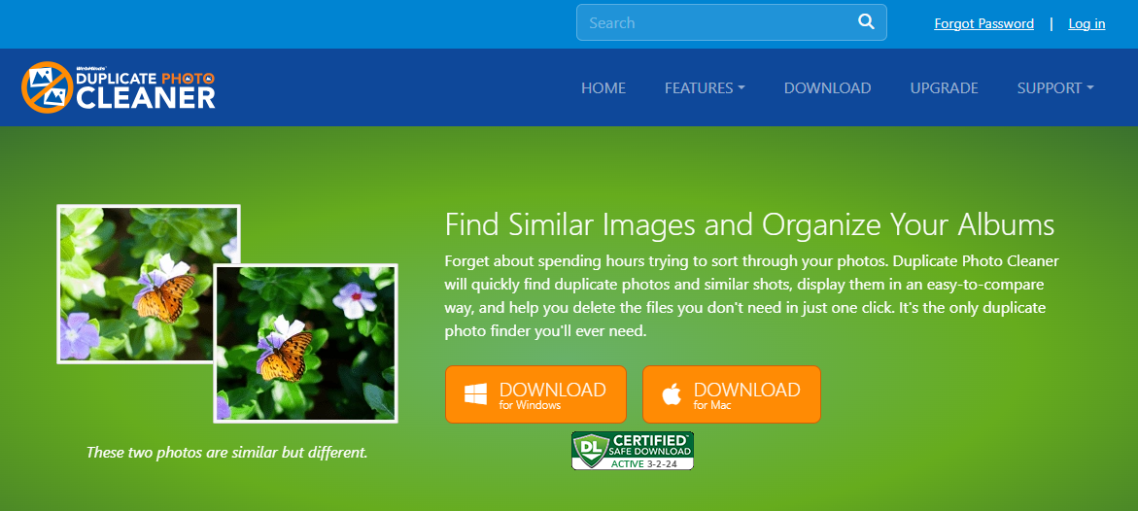

Figure 1 – Downloading the Duplicate Photo CleanerTM application installer executable file

**Tip:** After you click the above-mentioned links, you may be warned by your web-browser about a potential security risk due to the downloaded executable file. Please authorize this file.

You can follow the installation wizard by launching the downloaded Duplicate Photo Cleaner TM installer executable file to install the Duplicate Photo Cleaner TM application on your system.

**Tip:** After you open the downloaded executable file, you may be warned by your operating system before you can install this application on your system. Please authorize your operating system to continue installing this application at this step.

The next chapter gets you started with the Duplicate Photo Cleaner TM application that you just installed.

# Getting Started

Double click on the desktop icon of Duplicate Photo Cleaner application. Your DPC application will be launched as depicted in the figure below –

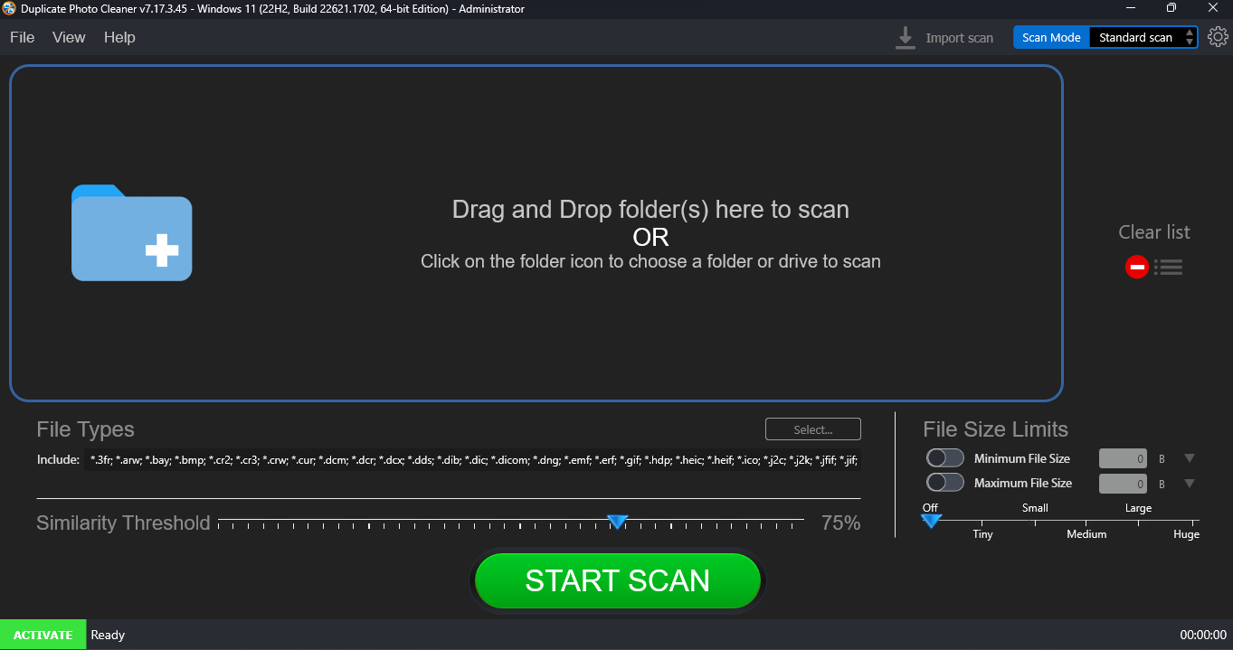

Figure 2 – Duplicate Photo CleanerTM default screen

Below is a description of the screen elements of the default screen of the TM application.

| **NO.** | **DESCRIPTION** |
| --- | --- |
| **1** | This is the main toolbar of the DPC application. The main operations that you can perform using the options on the toolbar are as follows –   * **File –** This option enables you to Start a Scan in the standard view as depicted in the figure above. * **Exit –** This option enables you to close from the DPC application. * **View –** This option enables you to change the view of photos as they are displayed on your screen in all of the modes. The common sub-options are – as a Table, Tree, Multiview, or Theatre. * **Help –** This option enables you to perform the following actions –   + **User Guide –** Clicking this option enables you to view this user guide.   + **Update –** Clicking this option enables you to check if any updates of the DPC application are available.   + **About -** Clicking this option enables you to view your license information in case you have registered DPC application installation. This option also enables to and purchase a license key depending on the package of your choice. Also, this sub-option enables you to register you application installation and activate it after the system validates your license key successfully.   **Reference:** To register your DPC application installation, refer to **Registering your DPC Application Installation** chapter by clicking this link.  **Reference:** To activate your DPC application installation, refer to **Activating your DPC Installation** chapter by clicking this link.  **Reference:** To remove your DPC application license details, refer to **Removing your DPC License Details** chapter by clicking this link. |
| **2** | Clicking this scan type drop-down list enables you to specify the scan type you intend to perform. Chapters 6 to Chapter 12 describe each scan type in detail. |
| **3** | This section indicates the current state of your DPC installation. In this case where it says **Activate**, indicates that your current DPC installation is not registered and activated.  **Reference:** An unregistered & inactivated DPC installation poses the 10-item clean limitation. To read more about this limitation, refer to the next sub-section. |

Limitations of Utilizing an Unregistered DPC Application in Trial Mode

The trial version of Duplicate Photo Cleaner offers unlimited scanning for duplicates and similar images in all scan types. You can then delete up to 10 duplicate groups with the trial version.

This is why it makes more sense to purchase a license package as per your usage use case scenario.

The next chapter describes steps that enable you to **Register your DPC Application Installation**.

# Registering your DPC Application Installation

The steps described below enable you to place a **Buy Now** request of the Duplicate Photo CleanerTM application via the Duplicate Photo CleanerTM homepage –

You can place a **Register** request in the following 2 ways –

## Via the DPC Homepage

The steps described below enable you to register the DPC application via the DPC homepage –

1. From the DPC application homepage, click the **Support > Register Your Product** link available in the menu on the DPC TM homepage as depicted in the figure below –

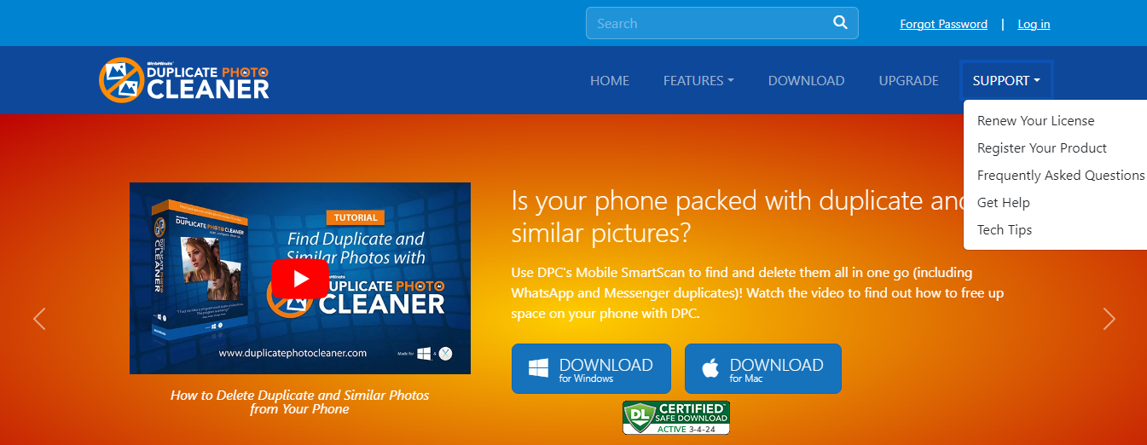

Figure 3 – Registering your DPC application installation via the DPCTM homepage

1. Click **Register** as depicted in the figure above. The register your software form is displayed as depicted in the figure below –

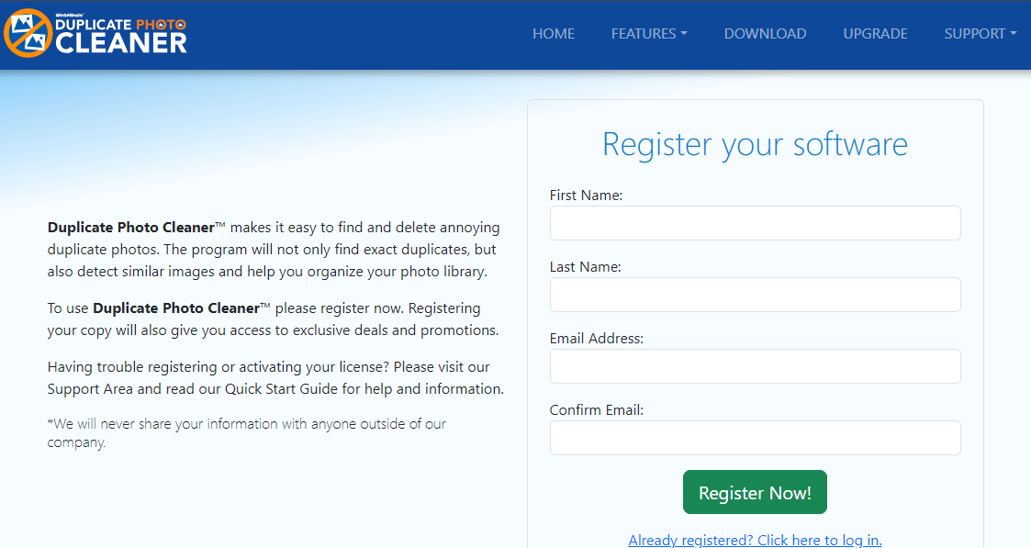

Figure 4 – Specifying your registration details

**Tip:** In case you have already registered, click the corresponding link provided under the **Register Now!** Button.

1. Specify your first name, last name, your email address, then confirm your email address & click **Register Now!**. The secure cart checkout page is displayed as depicted in the figure below –

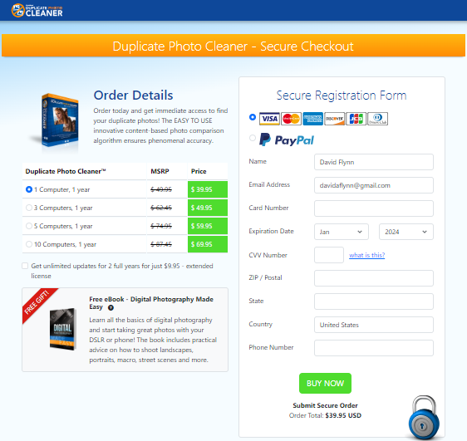

Figure 5 – Secure Registration page

1. Specify the required license options and your payment details & click **Buy Now**.

**Warning:** Ensure to double-check your specified details before you click **Buy Now**.

1. Once your payment details have been successfully processed, you will receive an email containing your DPCTM license key.

## Via the Register Button of DPC Application

The steps described below enable you to register the DPC application via the Register Button of DPC application –

1. After you launch the DPC application, the default screen is displayed as depicted in the figure below –

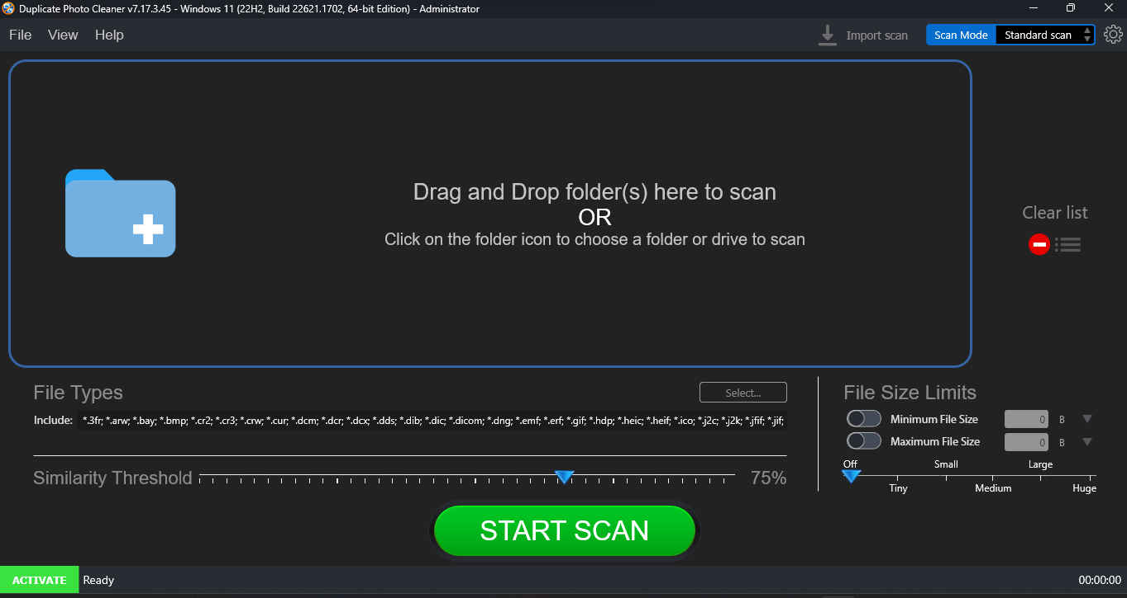

Figure 6 – DPC application default page

1. From the main toolbar menu, click **Help > About**. The DPC Product Key Details popup is displayed as depicted in the figure below –

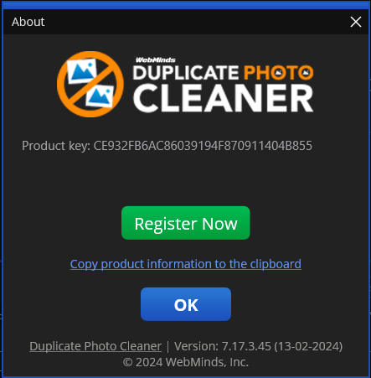

Figure 7 – DPC application license key specification – step 1

1. Click the **Register Now** button as depicted in the previous figure. The license registration key popup is displayed as depicted in the figure below –

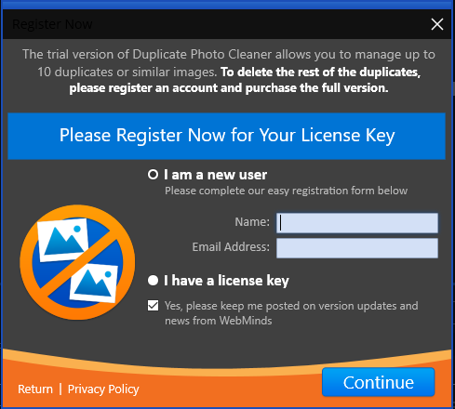

Figure 8 – DPC application license key specification – step 2

1. Select the **I have a license key** radio button as depicted in the figure above. The license registration key popup is displayed as depicted in the figure below –

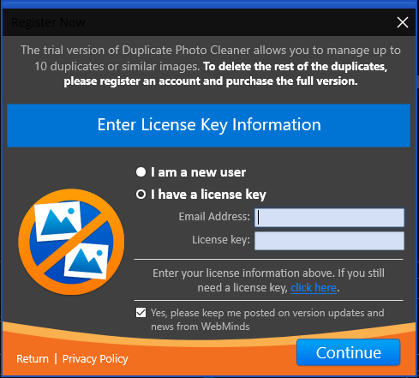

Figure 9 – DPC application license key specification – step 3

1. Specify your **Email Address** & **License Key** and click **Continue**. Your license key will be validated with our records and a successful activation popup message will be displayed as depicted in the figure below –

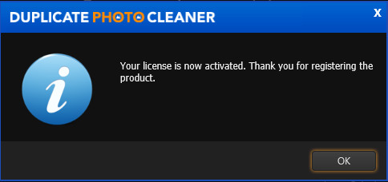

Figure 10 – DPC application license key activation successful

1. Click **OK** to continue. Now the 10-item duplicate photo limit will be removed and you can utilize all features of this application freely without any limitations.

The next chapter describes steps that enable you to **Activate your DPC Application**.

# Activating your DPC Installation

In case you have not activated your Duplicate Photo CleanerTM application as yet, you can utilize the steps described below –

1. After you launch the DPC application, the default screen is displayed as depicted in the figure below –



Figure 11 – DPC application default screen

1. From the main toolbar menu, click **Help > About**. The DPC Product Key Details popup is displayed as depicted in the figure below –



Figure 12 – Activating DPC application – step 1

1. Click the **Register Now** button as depicted in the previous figure. The license registration key popup is displayed as depicted in the figure below –



Figure 13 – Activating DPC application – step 2

1. Specify your **Name** & **Email Address** and click **Continue**. You will be redirected to the DPC Secure Checkout page. Using this webpage, you can specify a subscription plan of your choice, specify your identification details as required by this page, and make your payment. Post this, we will send you your license key on the email address that you specified on the registration popup.

The next chapter describes steps that enable you to **Remove your DPC License Key details**.

# Removing your DPC License Details

In case you intend to remove your DPC application license details so that you can use it on another system, you can utilize the steps described below –

**Warning:** You can only activate & remove your DPC license details 3 times post which this license will automatically expire.

1. After you launch the DPC application, the default screen is displayed as depicted in the figure below –



Figure 14 – DPC application default screen

1. From the main toolbar menu, click **Help > About**. The DPC Product Key Details popup is displayed as depicted in the figure below –

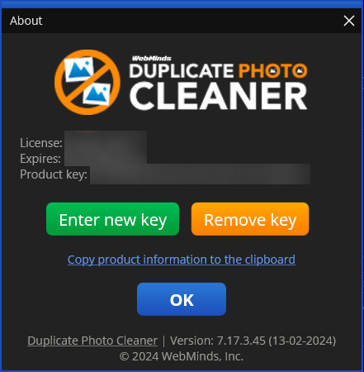

Figure 15 – Removing DPC application license key details – About popup

1. Click the **Remove Key** button as depicted in the previous figure. The license key removal confirmation popup is displayed as depicted in the figure below –

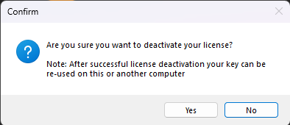

Figure 16 – Removing license key details confirmation popup

1. Click the **Yes** button. A successful license key removal confirmation messages is displayed as depicted in the figure below –

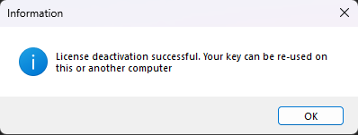

Figure 17 – Successful Removal of DPC application license key details

1. Click **OK** to continue. Now you can reuse this license key on another computer.

**Warning:** You can only activate & remove your DPC license details 3 times post which this license will automatically expire.

The next chapter describes steps that enable you to **Perform a Standard Scan**.

# Performing a Standard Scan

The steps described below enable you to perform offline data migration –

1. After you launch the Duplicate Photo CleanerTM application on your first or older PC, the default screen is displayed as depicted in the figure below –

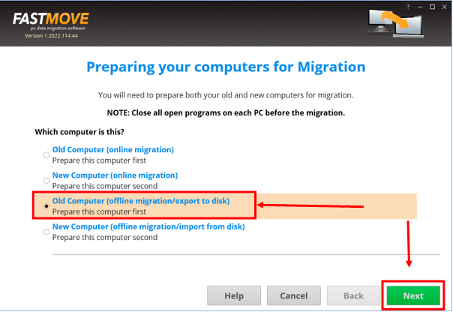

Figure 18 – Performing offline data migration

1. Select the **Old Computer (offline migration/export to disk)** option & click **Next**. The folder specification page is displayed as depicted in the figure below –

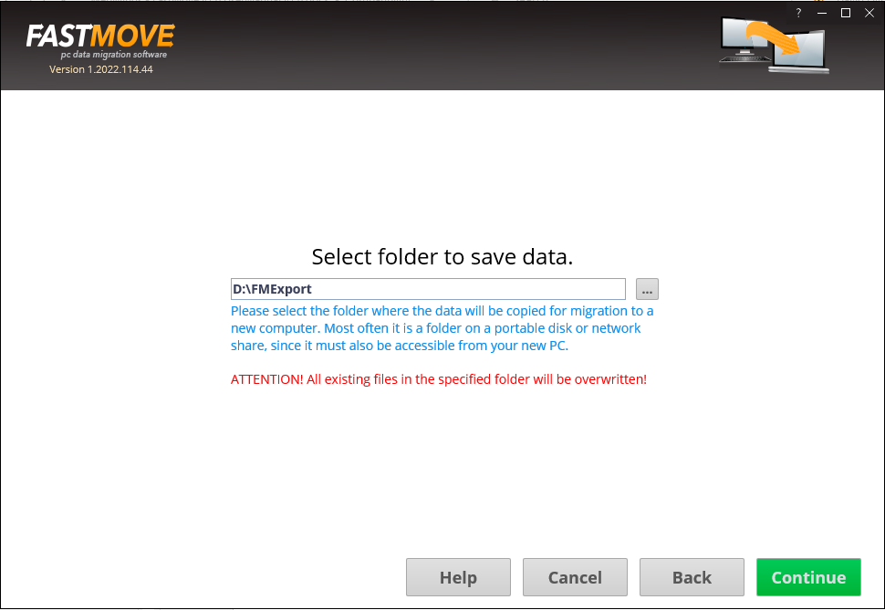

Figure 19 – Selecting a folder

**Tip:** Typically, this will be your external storage location.

1. Specify the folder to export your data by using the **Ellipsis (…)** button & click **Continue**. The custom file page is displayed as depicted in the figure below –

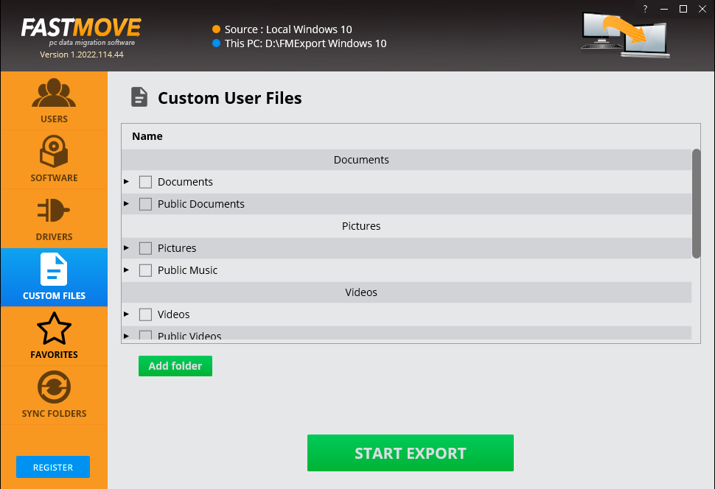

Figure 20 – Exporting you data folders & files

1. Select the folders that you intend to export and click **Start Export**.

Tip: You can specify more folders in case they are not available in this list by clicking **Add Export**.

The specified folder will be exported to the external storage location that you specified in step 2 in this section.

1. Now attach your external storage location to your second PC and launch the Duplicate Photo CleanerTM application.
2. After you launch the Duplicate Photo CleanerTM application on your second or newer PC, the default screen is displayed as depicted in the figure below –

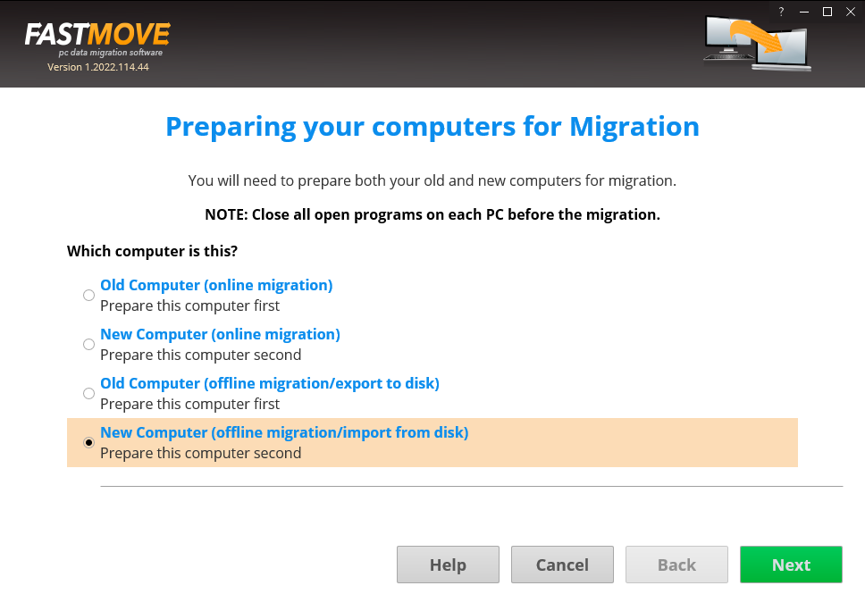

Figure 21 – Performing offline data migration

1. Select the **New Computer (offline migration/import from disk)** option & click **Next**. The folder specification page is displayed as depicted in the figure below –

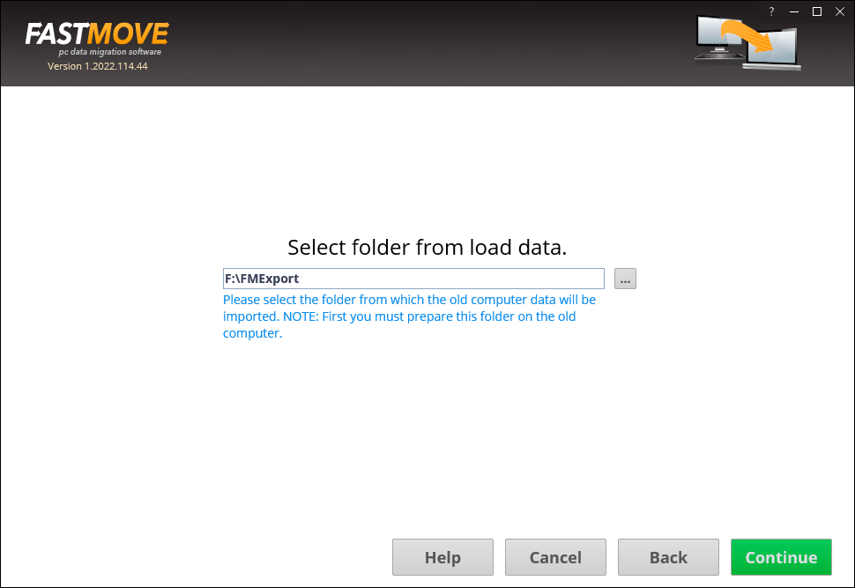

Figure 22 – Selecting a folder

**Tip:** Typically, this will be your external storage location.

1. Specify the folder to import your data from by using the **Ellipsis (…)** button & click **Continue**. The custom file page is displayed as depicted in the figure below –

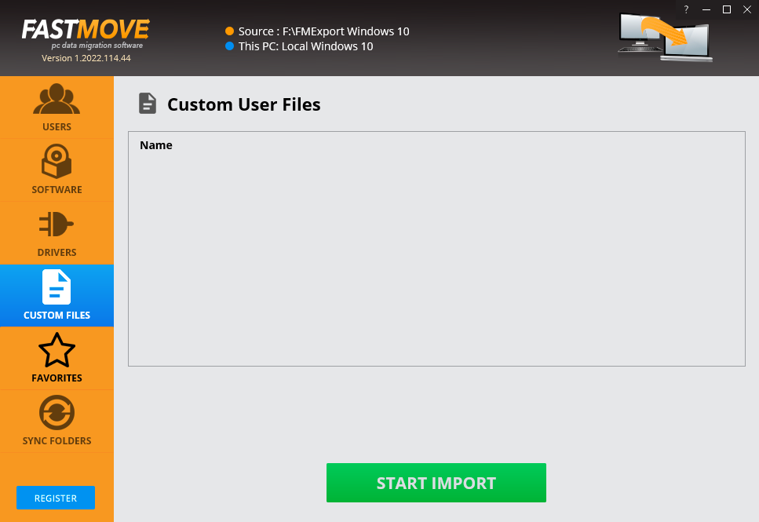

Figure 23 – Importing your data files & folders

1. Click **Start Import**. The specified folder will be imported to you second or new PC and a confirmation message will also be displayed.

**Tip:** Your files will be imported at the same path as your first or older PC.

The next chapter describes steps that enable you to **Perform Online Data Migration**.

# Performing a Mobile SmartScan

The steps described below enable you to perform online data migration –

1. Connect both your old & new PCs to the same network.

**Tip:** Ensure that both these PCs are discoverable to each other. Consult your network administrator or Windows Support. You may also require ensuring that you allow Duplicate Photo CleanerTM through the Windows Firewall on both PCs.

1. After you launch the Duplicate Photo CleanerTM application on your first or older PC, the default screen is displayed as depicted in the figure below –

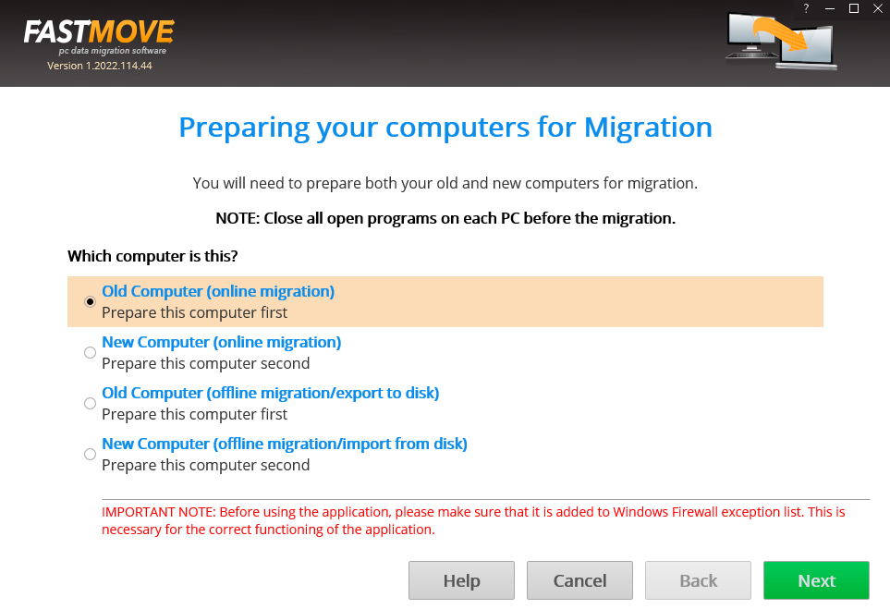

Figure 24 – Performing online data migration – PC1

1. Select the **Old Computer (offline migration/export to disk)** option on the first or old PC & click **Next**. Your IP Address details page is displayed as depicted in the figure below –

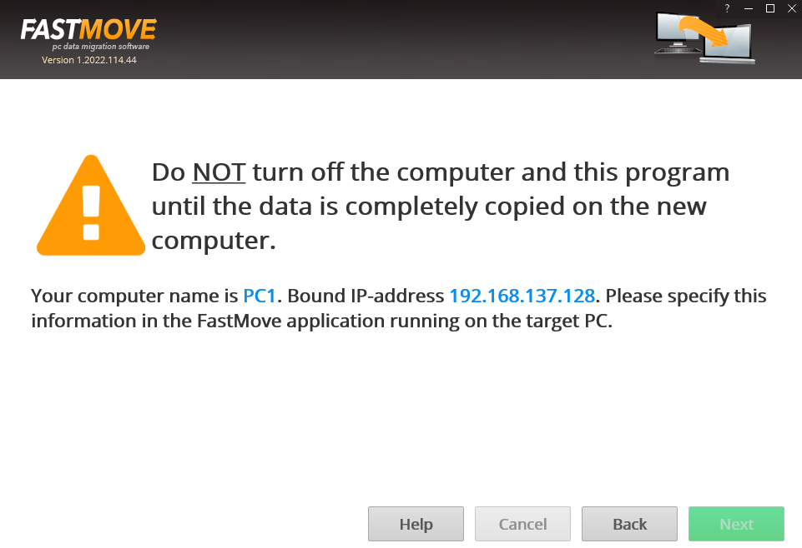

Figure 25 – Performing online data migration – PC2

1. Now on your second or newer PC, select the **New Computer (online migration)** option & click **Next** from the default screen is displayed as depicted in the figure below –

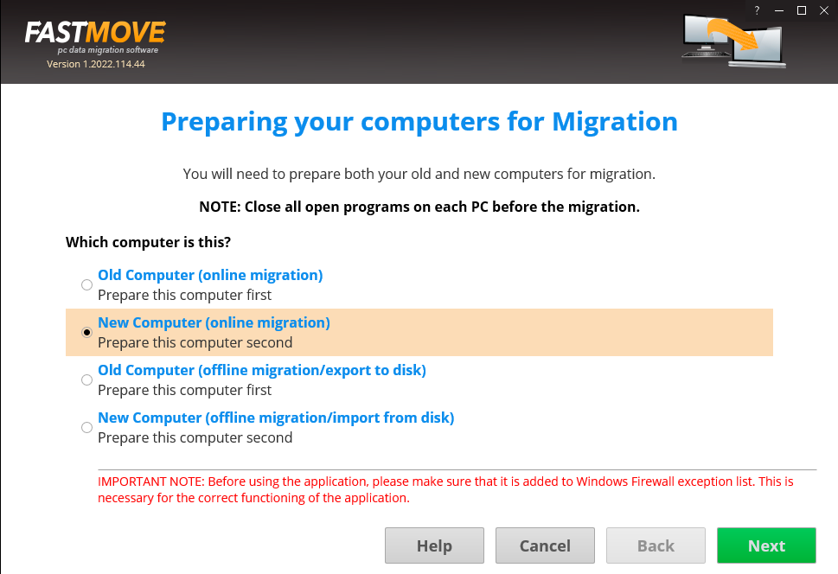

Figure 26 – Performing online data migration – PC2

The Duplicate Photo CleanerTM application will scan your network in order to look for your first or old PC automatically.

1. After your network has been successfully scanned, the IP Address details specification windows will be displayed as depicted in the figure below –

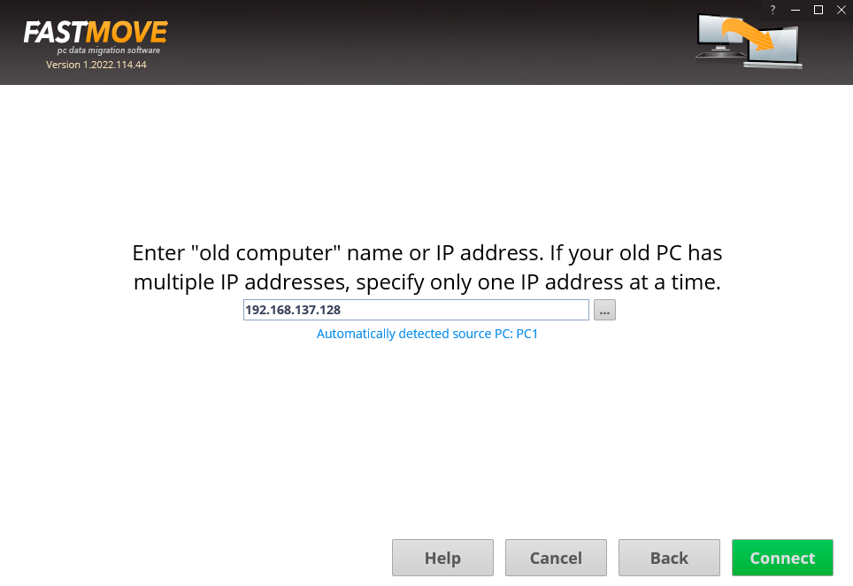

Figure 27 – Specifying the IP Adress of your second or newer PC

**Tip:** In case you do not see an automatically detected PC, consult your network administrator or Windows Support. You can also specify another IP Address in case you have multiple PCs connected to your network via the Duplicate Photo CleanerTM application by clicking the **Ellipses (…)** button.

1. Click **Connect**. The custom files window is displayed a depicted in the figure below –

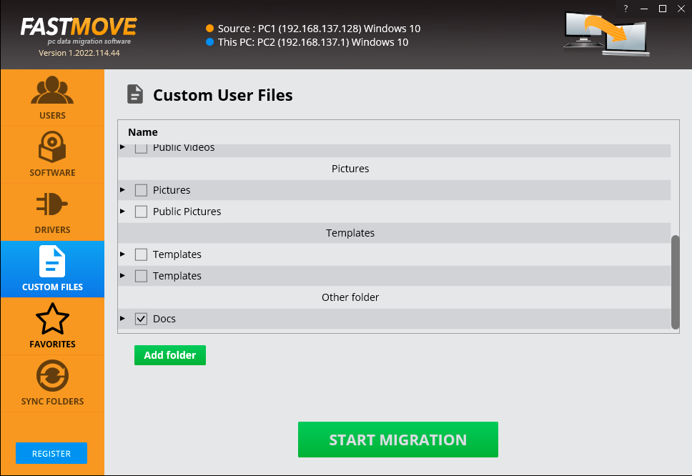

Figure 28 – Specifying the data folders & files to migrate from your first or older PC to your second or newer PC

1. Specify the folder to import your data from this dialog box or by clicking **Add Folder** button. The custom file page is displayed as depicted in the figure below –

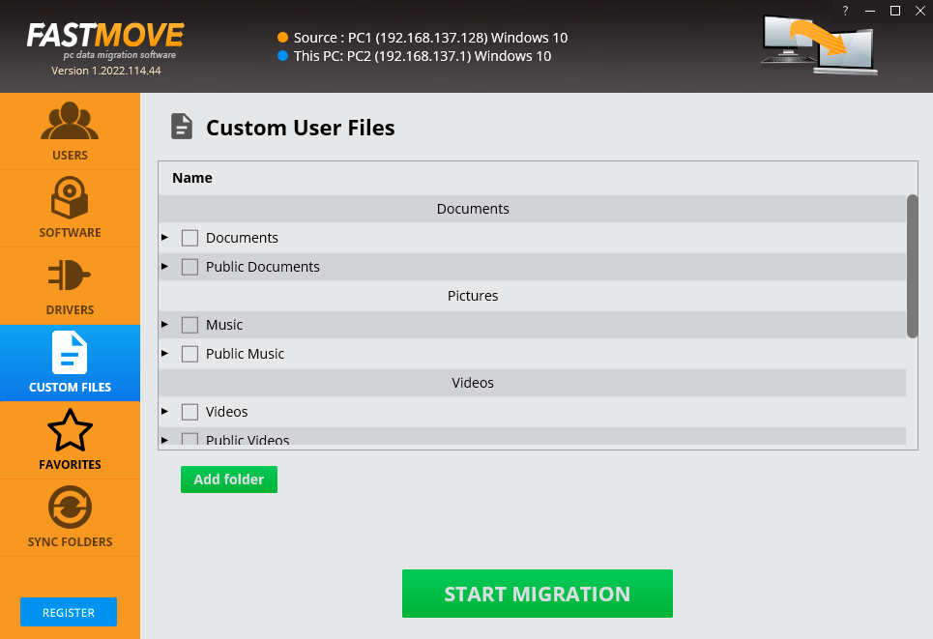

Figure 29 – Importing your data folders & files

Your files will be selected as depicted in the figure below –



Figure 30 – Selected data folders & files

1. Click **Start Migration**. Your data folders & files will be migrated and a confirmation message will be displayed as depicted in the figure below –

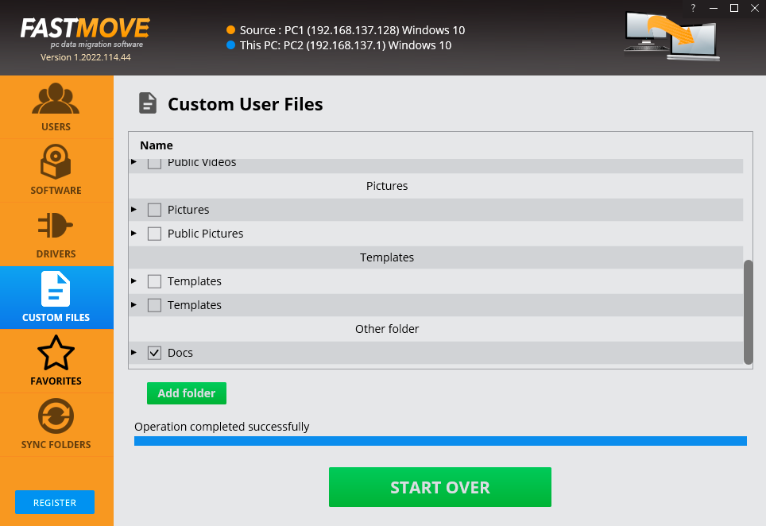

Figure 31 – Selected data folders & files

**Tip:** You can click **Start Over** to specify more data folders or files.

The next chapter describes steps that enable you to **Activate your Duplicate Photo CleanerTM installation**.

# Performing a Folder Comparison

Now that you have successfully registered & activated your Duplicate Photo CleanerTM application license key details, you can follow steps described in the **Performing**  chapter to migrate your users in the offline.

The steps described below enable you to perform users migration using the online method to save time, efforts, & reduce the number of migration iterations –

1. Connect both your old & new PCs to the same network.

**Tip:** Ensure that both these PCs are discoverable to each other. Consult your network administrator or Windows Support. You may also require ensuring that you allow Duplicate Photo CleanerTM through the Windows Firewall on both PCs.

1. After you launch the Duplicate Photo CleanerTM application on your first or older PC, the default screen is displayed as depicted in the figure below –



Figure 32 – Performing online data migration – PC1

1. Select the **Old Computer (offline migration/export to disk)** option on the first or old PC & click **Next**. Your IP Address details page is displayed as depicted in the figure below –



Figure 33 – Performing online data migration – PC2

1. Now on your second or newer PC, select the **New Computer (online migration)** option & click **Next** from the default screen is displayed as depicted in the figure below –



Figure 34 – Performing online data migration – PC2

The Duplicate Photo CleanerTM application will scan your network in order to look for your first or old PC automatically.

1. After your network has been successfully scanned, the IP Address details specification windows will be displayed as depicted in the figure below –



Figure 35 – Specifying the IP Adress of your second or newer PC

**Tip:** In case you do not see an automatically detected PC, consult your network administrator or Windows Support. You can also specify another IP Address in case you have multiple PCs connected to your network via the Duplicate Photo CleanerTM application by clicking the **Ellipses (…)** button.

1. Click **Connect**. The users window is displayed a depicted in the figure below –

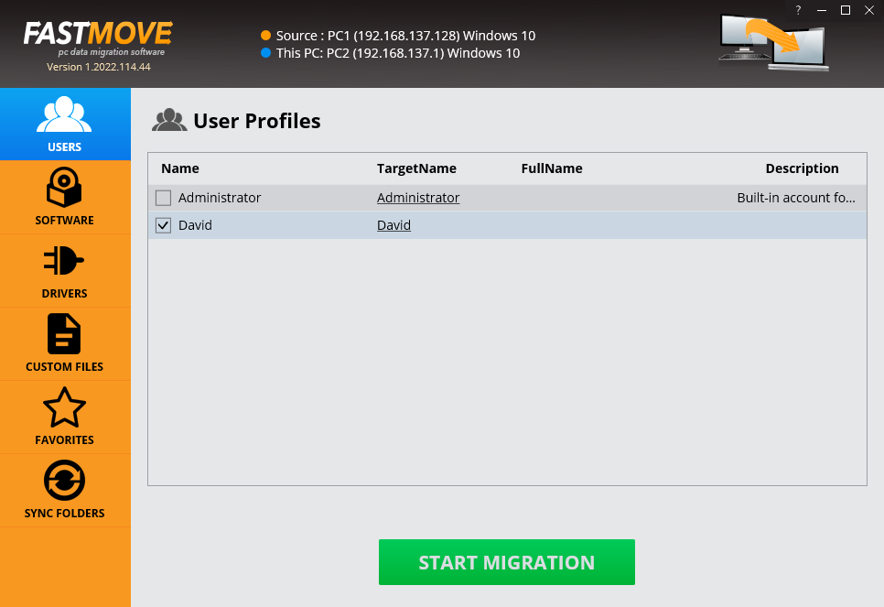

Figure 36 – Specifying the users to migrate from your first or older PC to your second or newer PC

1. Click **Start Migration**. The selected users will be migrated & a confirmation message will also be displayed on the screen.

The next chapter describes steps that enable you to **Perform Software Migration**.

# Performing a Picassa Scan

Now that you have successfully registered & activated your Duplicate Photo CleanerTM application license key details, you can follow steps described in the **Performing**  chapter to migrate your software in the offline mode in case you have an external storage device large enough to hold all your software.

The steps described below enable you to perform software migration using the online method to save time, efforts, & reduce the number of migration iterations –

1. Connect both your old & new PCs to the same network.

**Tip:** Ensure that both these PCs are discoverable to each other. Consult your network administrator or Windows Support. You may also require ensuring that you allow Duplicate Photo CleanerTM through the Windows Firewall on both PCs.

1. After you launch the Duplicate Photo CleanerTM application on your first or older PC, the default screen is displayed as depicted in the figure below –



Figure 37 – Performing online data migration – PC1

1. Select the **Old Computer (offline migration/export to disk)** option on the first or old PC & click **Next**. Your IP Address details page is displayed as depicted in the figure below –



Figure 38 – Performing online data migration – PC2

1. Now on your second or newer PC, select the **New Computer (online migration)** option & click **Next** from the default screen is displayed as depicted in the figure below –



Figure 39 – Performing online data migration – PC2

The Duplicate Photo CleanerTM application will scan your network in order to look for your first or old PC automatically.

1. After your network has been successfully scanned, the IP Address details specification windows will be displayed as depicted in the figure below –



Figure 40 – Specifying the IP Adress of your second or newer PC

**Tip:** In case you do not see an automatically detected PC, consult your network administrator or Windows Support. You can also specify another IP Address in case you have multiple PCs connected to your network via the Duplicate Photo CleanerTM application by clicking the **Ellipses (…)** button.

1. Click **Connect**. The users window is displayed a depicted in the figure below –

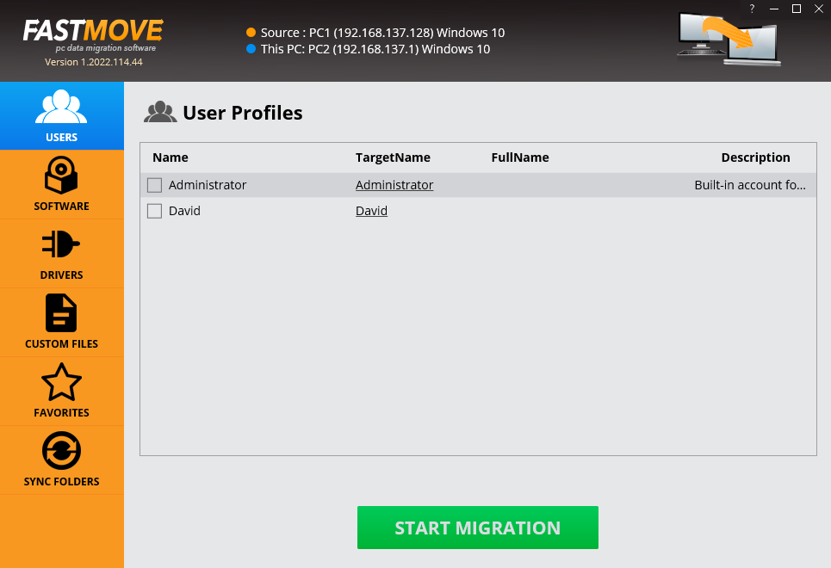

Figure 41 – Users screen

1. Then click **Software** from the left panel. The software window is displayed as depicted in the figure below –

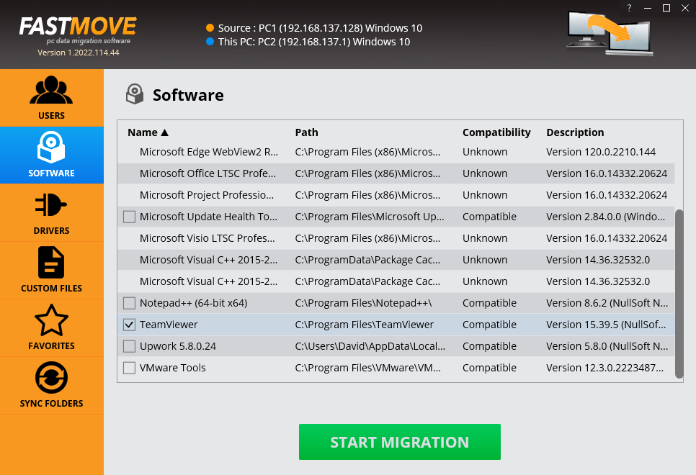

Figure 42 – Importing your software

1. Select the software you intend to migrate & click **Start Migration**. The selected software will be migrated & a confirmation message will also be displayed on screen.

The next chapter describes steps that enable you to **Perform Drivers Migration**.

# Performing a Lightroom Classic Scan

Now that you have successfully registered & activated your Duplicate Photo CleanerTM application license key details, you can follow steps described in the **Performing**  chapter to migrate your drivers in the offline mode in case you have an external storage device large enough to hold all your drivers.

The steps described below enable you to perform drivers migration using the online method to save time, efforts, & reduce the number of migration iterations –

1. Connect both your old & new PCs to the same network.

**Tip:** Ensure that both these PCs are discoverable to each other. Consult your network administrator or Windows Support. You may also require ensuring that you allow Duplicate Photo CleanerTM through the Windows Firewall on both PCs.

1. After you launch the Duplicate Photo CleanerTM application on your first or older PC, the default screen is displayed as depicted in the figure below –



Figure 43 – Performing online data migration – PC1

1. Select the **Old Computer (offline migration/export to disk)** option on the first or old PC & click **Next**. Your IP Address details page is displayed as depicted in the figure below –



Figure 44 – Performing online data migration – PC2

1. Now on your second or newer PC, select the **New Computer (online migration)** option & click **Next** from the default screen is displayed as depicted in the figure below –



Figure 45 – Performing online data migration – PC2

The Duplicate Photo CleanerTM application will scan your network in order to look for your first or old PC automatically.

1. After your network has been successfully scanned, the IP Address details specification windows will be displayed as depicted in the figure below –



Figure 46 – Specifying the IP Adress of your second or newer PC

**Tip:** In case you do not see an automatically detected PC, consult your network administrator or Windows Support. You can also specify another IP Address in case you have multiple PCs connected to your network via the Duplicate Photo CleanerTM application by clicking the **Ellipses (…)** button.

1. Click **Connect**. The users window is displayed a depicted in the figure below –



Figure 47 – Users screen

1. Now click **Drivers** from the left panel. The drivers window is displayed as depicted in the figure below –

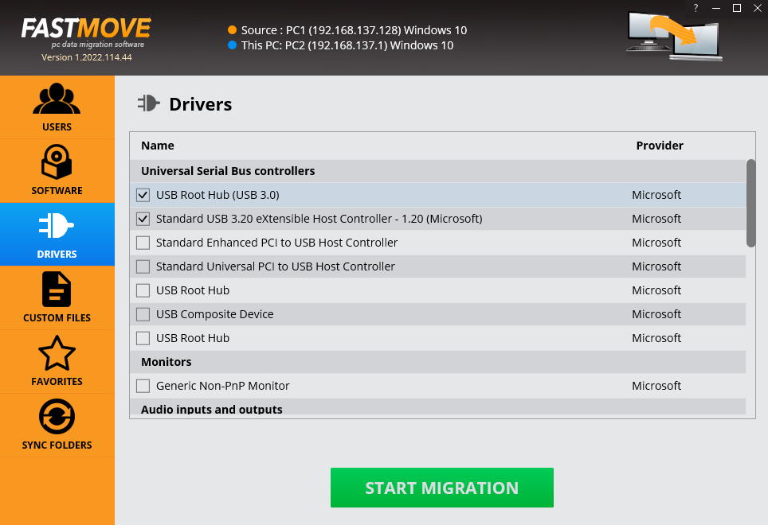

Figure 48 – Importing your drivers

1. Select the drivers that you intend to migrate & click **Start Migration**. The selected drivers will be migrated & a confirmation message will also be displayed on screen.

The next chapter describes steps that enable you to **Perform Favorites Migration**.

# Performing a PaintShop Pro Scan

Now that you have successfully registered & activated your Duplicate Photo CleanerTM application license key details, you can follow steps described in the **Performing**  chapter to migrate your favorites in the offline mode in case you have an external storage device large enough to hold all your favorites.

The steps described below enable you to perform favorites migration using the online method to save time, efforts, & reduce the number of migration iterations –

1. Connect both your old & new PCs to the same network.

**Tip:** Ensure that both these PCs are discoverable to each other. Consult your network administrator or Windows Support. You may also require ensuring that you allow Duplicate Photo CleanerTM through the Windows Firewall on both PCs.

1. After you launch the Duplicate Photo CleanerTM application on your first or older PC, the default screen is displayed as depicted in the figure below –



Figure 49 – Performing online data migration – PC1

1. Select the **Old Computer (offline migration/export to disk)** option on the first or old PC & click **Next**. Your IP Address details page is displayed as depicted in the figure below –



Figure 50 – Performing online data migration – PC2

1. Now on your second or newer PC, select the **New Computer (online migration)** option & click **Next** from the default screen is displayed as depicted in the figure below –



Figure 51 – Performing online data migration – PC2

The Duplicate Photo CleanerTM application will scan your network in order to look for your first or old PC automatically.

1. After your network has been successfully scanned, the IP Address details specification windows will be displayed as depicted in the figure below –



Figure 52 – Specifying the IP Adress of your second or newer PC

**Tip:** In case you do not see an automatically detected PC, consult your network administrator or Windows Support. You can also specify another IP Address in case you have multiple PCs connected to your network via the Duplicate Photo CleanerTM application by clicking the **Ellipses (…)** button.

1. Click **Connect**. The users window is displayed a depicted in the figure below –



Figure 53 – User screen

1. Now click **Favorites** from the left panel. The favorites window is displayed as depicted in the figure below –

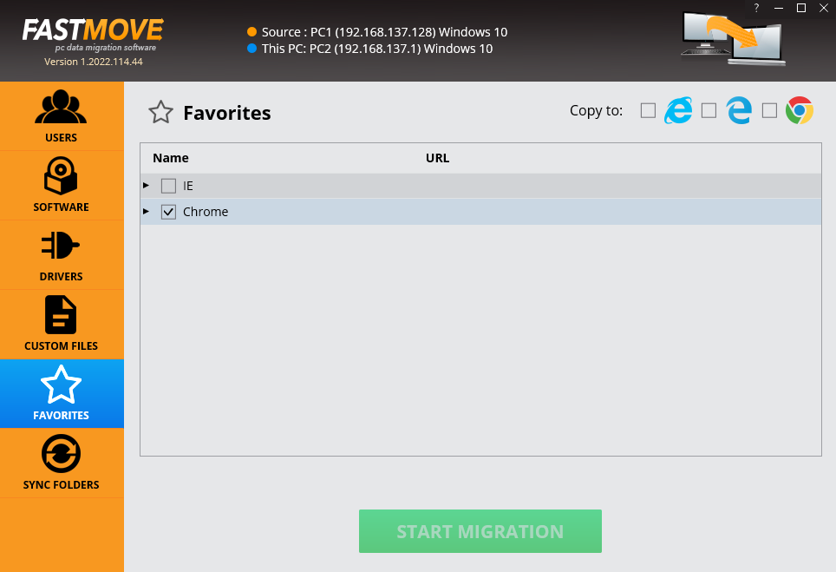

Figure 54 – Importing your favorites from your default browser

1. Select the favorites that you intend to migrate & click **Start Migration**. Your selected favorites will be migrated & a confirmation message will be on screen.

The next section of this user manual **Frequently Asked Questions (FAQs)** as an appendix.

# Performing a Fragment Search

Now that you have successfully registered & activated your Duplicate Photo CleanerTM application license key details, you can follow steps described in the **Performing**  chapter to migrate your favorites in the offline mode in case you have an external storage device large enough to hold all your favorites.

The steps described below enable you to perform favorites migration using the online method to save time, efforts, & reduce the number of migration iterations –

1. Connect both your old & new PCs to the same network.

**Tip:** Ensure that both these PCs are discoverable to each other. Consult your network administrator or Windows Support. You may also require ensuring that you allow Duplicate Photo CleanerTM through the Windows Firewall on both PCs.

1. After you launch the Duplicate Photo CleanerTM application on your first or older PC, the default screen is displayed as depicted in the figure below –



Figure 55 – Performing online data migration – PC1

1. Select the **Old Computer (offline migration/export to disk)** option on the first or old PC & click **Next**. Your IP Address details page is displayed as depicted in the figure below –



Figure 56 – Performing online data migration – PC2

1. Now on your second or newer PC, select the **New Computer (online migration)** option & click **Next** from the default screen is displayed as depicted in the figure below –



Figure 57 – Performing online data migration – PC2

The Duplicate Photo CleanerTM application will scan your network in order to look for your first or old PC automatically.

1. After your network has been successfully scanned, the IP Address details specification windows will be displayed as depicted in the figure below –



Figure 58 – Specifying the IP Adress of your second or newer PC

**Tip:** In case you do not see an automatically detected PC, consult your network administrator or Windows Support. You can also specify another IP Address in case you have multiple PCs connected to your network via the Duplicate Photo CleanerTM application by clicking the **Ellipses (…)** button.

1. Click **Connect**. The users window is displayed a depicted in the figure below –



Figure 59 – User screen

1. Now click **Favorites** from the left panel. The favorites window is displayed as depicted in the figure below –



Figure 60 – Importing your favorites from your default browser

1. Select the favorites that you intend to migrate & click **Start Migration**. Your selected favorites will be migrated & a confirmation message will be on screen.

The next section of this user manual **Frequently Asked Questions (FAQs)** as an appendix.

1. Frequently Asked Questions (FAQs)

Here is a list of frequently asked questions with reference to the Duplicate Photo CleanerTM application and its usage –

Why do I need Duplicate Photo Cleaner™?

Duplicate Photo CleanerTM is the app that makes it easy to move all your files, user profiles, settings, software and even drivers from one computer to another. It's perfect for configuring a new computer with all your stuff, syncing folders, and keeping data and settings the same on two or more computers.

Which Operating Systems does Duplicate Photo CleanerTM work with?

Duplicate Photo CleanerTM supports Windows 7 - Windows 11, 32-bit and 64-bit versions. You can use it to move data between different versions of Windows operating systems. In some cases, 64-bit apps may not be compatible with a 32-bit operating system. Whenever a problem like that arises, Duplicate Photo CleanerTM will tell you which apps couldn't be moved and why.

Can I use Duplicate Photo CleanerTM to transfer data between Windows & Mac?

No. Currently, Duplicate Photo CleanerTM only supports Windows operating systems.

What’s the best way to ensure that the software I moved to my new PC runs without errors?

Once you've moved your software to your new computer, run each migrated app as administrator when you use it for the first time. To do that, right-click on the program's icon and select "Run as Administrator".

Can I choose what I want to migrate?

Absolutely! You don't have to move everything from the old computer unless you want to. Use the checkboxes to select what you want to migrate and follow the app's prompts.

What does the Sync Folders feature do?

Sync Folders is a sync tool that you can use both locally and between two computers. Here's how to use it if both computers are connected to a network:

1. Select two folders you want to compare.
2. Duplicate Photo CleanerTM will scan them and show you which files are different.
3. You can then sync the folders between both PCs.

If the computers aren't connected to the same network and you're using offline migration, do the following:

1. Select the folder you want to sync on the source PC.
2. Sync it with the offline folder you've chosen for offline migration.
3. Sync the offline folder with the desired folder on the target PC.

Can I transfer data using Duplicate Photo CleanerTM if my computer is offline?

Yes, you can use Offline Migration:

1. First, open Duplicate Photo CleanerTM on the computer you want to copy the data from and select the "Old Computer (offline migration/export to disk)" option, then click "Next".
2. Select a folder where you want to copy the data. Make sure the folder is located on removable media (an external hard drive or a USB thumb drive, depending on how much data you want to copy) or is a network folder. This way you will be able to access data from the target computer while offline. Once you've selected the folder, click "Continue".
3. On the next screen, select what you want to migrate using the checkboxes. When you're ready to start copying data, click on "Start Export" and wait for the export process to finish.
4. When all the data has been copied to the target folder, connect it to the computer you want to copy the data to. Then open Duplicate Photo CleanerTM on the destination computer, select the "New Computer (offline migration/import from disk)" radio button, and select the data you want to import.

If you don't have access to an external hard drive or a network folder, you can perform offline migration with the help of a compatible USB cable that supports data transfer between two PCs:

1. Open Duplicate Photo CleanerTM on the source computer and select a folder on that computer's hard drive where you'd like to export data.
2. Connect your old and new computers using a compatible USB cable and copy the folder with your Duplicate Photo CleanerTM export to the new computer.
3. Open Duplicate Photo CleanerTM on the destination computer, select the "New Computer (offline migration/import from disk)" radio button, and select the folder you've just copied you want to import.
4. Start the export and wait for Duplicate Photo CleanerTM to finish migrating data.

**Tip:** To view detailed steps, refer to the **Performing**  chapter.

Does the Sync Folder feature work in offline mode?

Yes, it works just like offline migration, which means that you'll first need to sync the folder from your Source PC with an offline folder (i.e. a folder on a removable or network drive), then connect it to the target PC and sync the offline folder with the target PC.

Can I migrate data from an HDD to an SSD using Duplicate Photo CleanerTM?

Absolutely! Duplicate Photo CleanerTM supports both drive types.

When I migrate software using Duplicate Photo CleanerTM, does it also transfer license information?

No. Software licensing works in such a way that a license can't be migrated to another PC unless you have a multiple-PC license or your software supports license deactivation and reactivation. We recommend you to save your license keys and make sure you can reactivate your apps before you perform software migration.

How can I be sure that the drivers I transferred will be compatible with the new one?

When Duplicate Photo Cleaner prepares device drivers for migration, it checks driver properties for a list of compatible operating systems and only transfers compatible drivers.

When I install a program on a PC, most of the times there are brand new registry updates & configuration files. Does Duplicate Photo CleanerTM create the same registry updates & files on the new PC?

When copying user software to a new PC, Duplicate Photo CleanerTM will only copy registry entries, folders and files created by the installer of this software. It will not remove any entries from the source PC.

If I install OEM software requiring a license & I want to move that software to a different PC, will it still be available on the source PC or will Duplicate Photo CleanerTM remove it when it installs the software on the destination PC?

The software will still be available on the source PC because Duplicate Photo Cleaner will simply COPY it to the target PC, leaving your source PC intact.

Will Duplicate Photo CleanerTM move the emails from my email client such as Microsoft Outlook?

Yes, all your email data will be transferred as part of your user profile as long as you perform user profile migration.

What are the trial version limitations?

The trial version of Duplicate Photo CleanerTM allows you to migrate custom files and favorites for an unlimited number of times. You'll need to purchase the full version to migrate software, users, drivers, and sync folders.

**Tip:** For more information, refer to the I want to uninstall Duplicate Photo CleanerTM from my current PC & install it on another one using my license key. How to do it?

If you ever need to reinstall the program or move it to a different computer, you can go to the "About" screen inside the program, make a note of your license key and then remove it. This will reset the key so that you can reactivate it on a new installation (this feature is limited to 3 times).

Why is there an expiration date on my license?

When you purchase a Duplicate Photo CleanerTM license, the license unlocks the program forever, so that you can use it for as long as you want. As for the expiry date, it's set to show you the period during which you will be able to download free updates. Once the license expires, you can continue using your version of the program, but you will need to extend your license to continue getting updates and have access to email support.

Remember that each computer is assigned a unique license ID. Once activated, the software will not work on any other computer unless you either remove the key using the "About" screen in the program.

I’m trying to register Duplicate Photo CleanerTM but it’s not working. What to do?

There are a few things that may prevent the activation of the product, including:

* Your UAC (User Account Control) settings in Windows Vista, Windows 7, Windows 8, Windows 10 and Windows 11. When that's the case, simply close Duplicate Photo Cleaner™, then right-click on its shortcut on your desktop and select "Run as administrator". Then proceed to register the program.
* Your firewall or anti-virus programs may be preventing changes to your computer. Even ones you want to make such as registering your product. Try disabling your security software temporarily and proceed with product registration.

Can I activate Duplicate Photo CleanerTM on my old & new computer using the same license key?

Yes! Each license key is good for a pair of computers, the source PC you're copying data from and the target PC you're migrating to. For example, if you have a single Duplicate Photo CleanerTM license, you can use it on two computers. If you purchased a license for 3 PCs, you can use it to activate Duplicate Photo CleanerTM on 6 PCs and use the software to move data between them, and so on.

I’m trying to install Duplicate Photo CleanerTM but my computer won’t let me. What to do?

Most likely, your computer needs you to run the installer as Administrator. Here is how you can do that:

1. Right-click on the fm_setup.exe file
2. Select "Run as Administrator..."
3. Follow the setup instructions.

I accidently closed Duplicate Photo CleanerTM during data transfer. Will any of the files become corrupted because of that?

Don't worry, your files and other data are safe. When you accidentally close Duplicate Photo CleanerTM during data migration, it will simply cancel the process and go back to the welcome screen where you can start data transfer again.

I was about to install Duplicate Photo CleanerTM but I received a warning from my firewall that Duplicate Photo CleanerTM was attempting to access the network?

Duplicate Photo CleanerTM is a network tool, which means that it needs access to your network to work properly. Access to local area network is needed for the app to establish communication between source and target PCs. Move it to your firewall's whitelist.

I can’t seem to make online data migration work. What to do?

First of all, make sure that you have Duplicate Photo CleanerTM installed and activated on both your old and new computers.

Secondly, check your network settings and make sure that password-protected sharing is disabled and public folder sharing is turned on. You can always change these settings back once the migration is complete.

And lastly, disable your antivirus software before migrating data to prevent it from blocking the transfer.

How to move a profile from a Windows 10 PC to a new Windows 11 PC?

* Only new users should be migrated. Otherwise, the user will lose all data related to the existing account on the target computer.
* The user profile must not exist on the target computer. If the profile exists, the user can rename the target user and/or delete it.
* The user whose profile is being transferred must log out. This means that a user must have at least two administrators to be able to migrate each other.

Can I migrate user profiles?

* Duplicate Photo Cleaner enables users to migrate their profiles to a new PC, if those profiles do not already exist on the destination machine.
* Duplicate Photo Cleaner safeguards against overwriting existing profiles on the target PC when the same user already exists there.

How to delete user profiles?

Customers can effortlessly remove user accounts they no longer require. Please note that only profiles of users who are not currently logged in can be deleted.

Furthermore, any user profile can be deleted through Advanced System Properties:

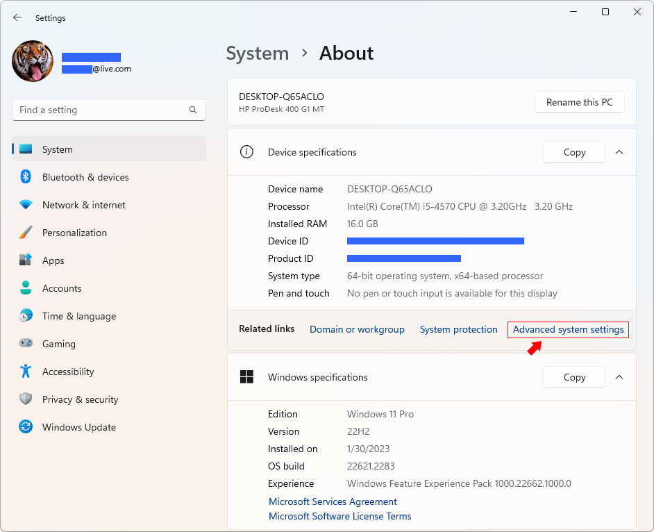

Figure 61 – Advanced system settings

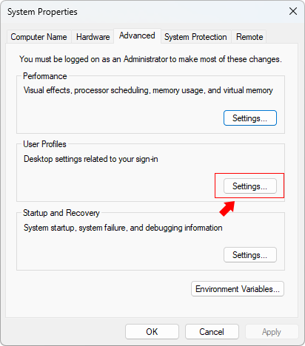

Figure 62 – System Properties > User Profiles > Settings

Can I migrate everything all at once?

Yes, but this is not recommended. We recommend to migrate entities from one "tab" at a time: User Profiles, then Software, then Drivers (only for PC with same hardware), then Favorites, etc. The newer version will not allow to migrate everything at once to avoid issues.

Can I migrate old drivers to new PC with different hardware components?

There is no need to migrate drivers from an old system to the new hardware if that hardware does not exist on the new PC. This is only applicable to detachable hardware like Printers, Scanners and other external hardware.

Error “The password does not match the password policy criteria…”

Typically indicates that the target PC is likely part of an NT domain and/or has stringent security policies in place.

Error “The specified file was not found”

Occurred while Duplicate Photo CleanerTM attempted to copy C:\Windows\System32\atl100.dll during software migration within the directory C:\Program Files\Druide\Connectix 10. This issue likely stems from an incorrect installation of the product (Connectix 10).

No checkbox, Unable to Select Software

Explanation: This is not supported, and Duplicate Photo CleanerTM may encounter difficulties in transferring it accurately. This is often the case when a software employs its own custom installation engine.

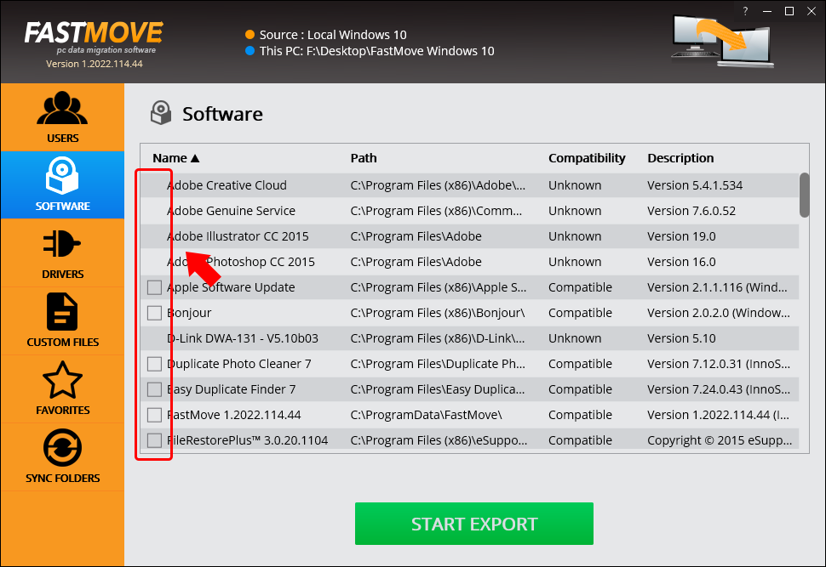

Figure 63 – System Properties > User Profiles > Settings

The next section of this user manual includes an **Index** of frequently referred terms or phrases with reference to the Duplicate Photo CleanerTM application and its usage.

Index

A

Abbreviations / Acronyms used in this User Manual vi

About this User Manual iii

Activating your DPC Installation 20

C

Can I activate Duplicate Photo CleanerTM on my old & new computer using the same license key? 64

Can I choose what I want to migrate? 59

Can I migrate data from an HDD to an SSD using Duplicate Photo CleanerTM? 60

Can I migrate everything all at once? 68

Can I migrate old drivers to new PC with different hardware components? 68

Can I migrate user profiles? 66

Can I transfer data using Duplicate Photo CleanerTM if my computer is offline? 59

Can I use Duplicate Photo CleanerTM to transfer data between Windows & Mac? 58

D

Does the Sync Folder feature work in offline mode? 60

Downloading the DPC Application Installer 10

E

Error “The password does not match the password policy criteria…” 68

Error “The specified file was not found” 68

F

Frequently Asked Questions (FAQs) 58

G

Getting Started 12

H

How can I be sure that the drivers I transferred will be compatible with the new one? 62

How to delete user profiles? 67

How to move a profile from a Windows 10 PC to a new Windows 11 PC? 66

I

I accidently closed Duplicate Photo CleanerTM during data transfer. Will any of the files become corrupted because of that? 65

I can’t seem to make online data migration work. What to do? 65

I want to uninstall Duplicate Photo CleanerTM from my current PC & install it on another one using my license key. How to do it? 63

I was about to install Duplicate Photo CleanerTM but I received a warning from my firewall that Duplicate Photo CleanerTM was attempting to access the network? 65

I’m trying to install Duplicate Photo CleanerTM but my computer won’t let me. What to do? 64

I’m trying to register Duplicate Photo CleanerTM but it’s not working. What to do? 64

If I install OEM software requiring a license & I want to move that software to a different PC, will it still be available on the source PC or will Duplicate Photo CleanerTM remove it when it installs the software on the destination PC? 62

In Scope of this User Manual iii

Intended Audience of this User Manual iii

Introduction 10

L

Limitations of Utilizing an Unregistered DPC Application in Trial Mode 13

N

No checkbox, Unable to Select Software 69

O

Organization of this User Manual iii

Out of Scope of this User Manual iii

P

Performing a Folder Comparison 36

Performing a Fragment Search 53

Performing a Lightroom Classic Scan 44

Performing a Mobile SmartScan 30

Performing a PaintShop Pro Scan 48

Performing a Picassa Scan 40

Performing a Standard Scan 26

Purpose of this User Manual iii

R

Registering your DPC Application Installation 14

Removing your DPC License Details 23

T

Terms Used in this User Manual vi

Typographical Conventions / Customaries used in this User Manual v

V

Via the DPC Homepage 14

Via the Register Button of DPC Application 17

W

What are the trial version limitations? 63

What does the Sync Folders feature do? 59

What’s the best way to ensure that the software I moved to my new PC runs without errors? 58

When I install a program on a PC, most of the times there are brand new registry updates & configuration files. Does Duplicate Photo CleanerTM create the same registry updates & files on the new PC? 62

When I migrate software using Duplicate Photo CleanerTM, does it also transfer license information? 60

Which Operating Systems does Duplicate Photo CleanerTM work with? 58

Why do I need Duplicate Photo Cleaner™? 58

Why is there an expiration date on my license? 63

Will Duplicate Photo CleanerTM move the emails from my email client such as Microsoft Outlook? 63